**PDC FISAC**

Registration number:220953654

Name: Chaitanya Kannan

Section: CCE-A

Roll Number:60

MODULATION TECHNIQUE: DPSK

**BLOCK DIAGRAM:**

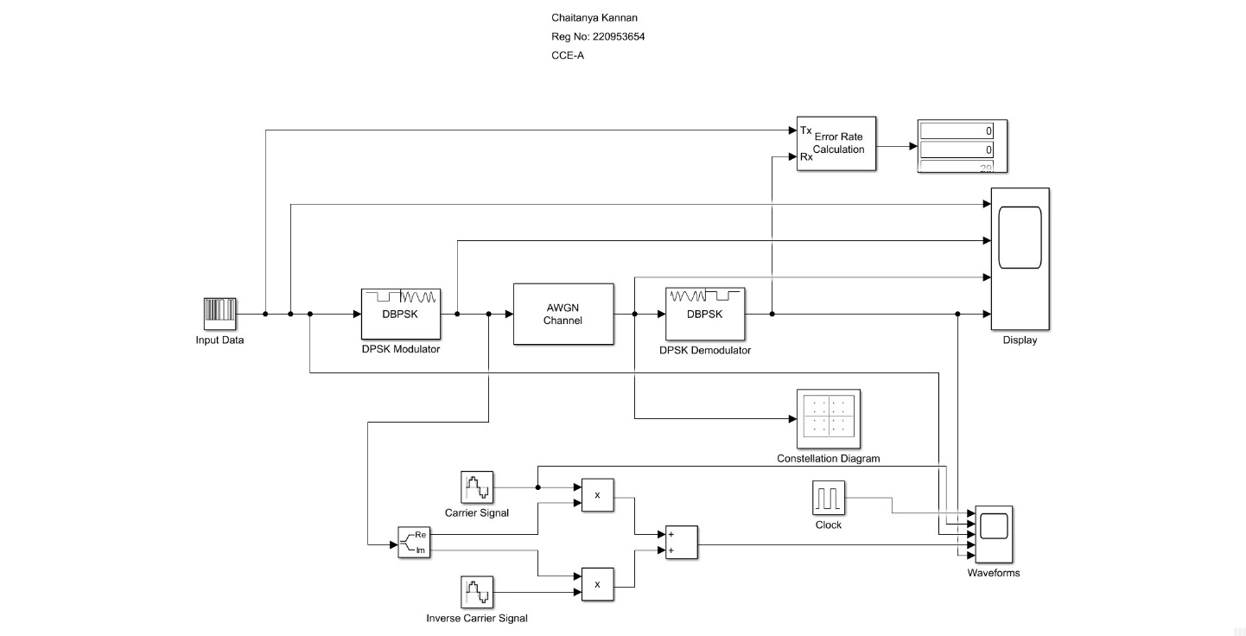

**BLOCKS USE:**

1.DBPSK Modulator:DBPSK (Differential Binary Phase Shift Keying) modulator is a digital modulation scheme where the phase of the transmitted signal is shifted based on the difference between consecutive binary symbols.

2.Carrier Signal: A carrier signal is a high-frequency waveform used to modulate a lower-frequency information signal for efficient transmission in communication systems.

3.Inverse Carrier Signal: The inverse carrier signal is utilized to demodulate a modulated signal, extracting the original information signal in communication systems.

4.AWGN Channel: adds white noise to channel

5.Clock:a clock signal is used to synchronize and control the timing of the modulating signal, ensuring accurate and consistent frequency variations, which is essential for reliable data transmission in communication systems.

6.Constellation Diagram: displays constellation diagram

7.DPSK Demodulator: A DPSK (Differential Phase Shift Keying) demodulator is employed to extract digital information by detecting and interpreting changes in the phase of consecutive symbols in the received signal.

8.Error Rate Calculator: calculates error rate

9.Display: displays error rate

10.Complex-Real and Imaginary : displays constellation diagram

**CONSTELLATION DIAGRAM:**

**SCOPE:**

